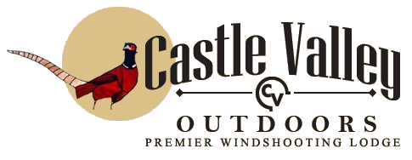

What To Bring
This is the high desert west (annual rainfall 6 - 8 inches) and temperatures can vary some 30 degrees from morning to evening. Because Castle Valley Outdoors sits at an altitude of approximately 6,000 to 7,000 feet knowing how to dress can make all the difference.
During the summer months temperatures average in the 80's to mid 90's with evening cool downs into the 60's which is very delightful after a full day of outdoor activities. If you plan to join us during the summer months, here is a list of suggested items you may want to pack along:
- T-shirts and long-sleeved shirts
- Jeans
- Several pairs of socks
- Boots (or closed-toe shoes like hiking boots or sneakers)
- Jacket or sweater (evenings can be cool)
- Cap, cowboy hat
- Leather gloves if you have them
- Sunscreen, sunglasses
- Camera
- Prescription medicine
- Hand lotion, chap stick
- Camera
- Binoculars
- Pocket knife
- Small flashlight
- Optional: Small fanny pack or backpack, fishing vest
In the winter, temperatures average somewhere between 30 and 40 with evening temps dropping well below freezing. If your visit will be during the winter months, we suggest you include the following:
- Fleece pullover
- Flannel shirts
- Warm winter jacket or coat
- Thermal underwear
- Warm hat (should cover your ears)
- Winter boots
- Heavy winter socks
- Warm insulated gloves

